How to Use Private Print Jobs on Kyocera Copier
When printing your item, click on the Printer Properties link in the print window.
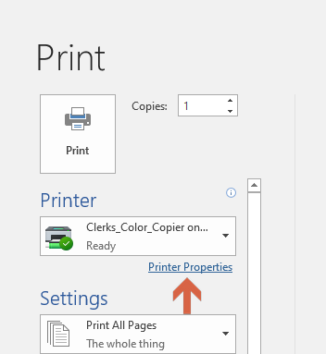
This will bring up the Printer Properties Window for the selected Copier. Click the Job tab.
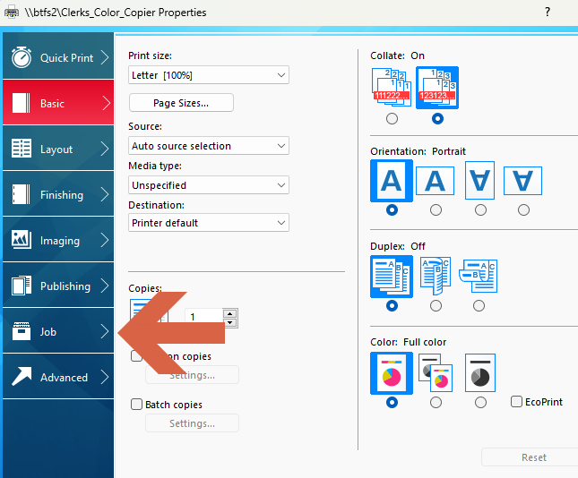
In the Job window:
- Click the check box on Job Storage.
- Using the pull-down menu select Private Print.
- Uncheck Prompt for Access Code and then put in a 4 digit access code in the Specify Access Code field.
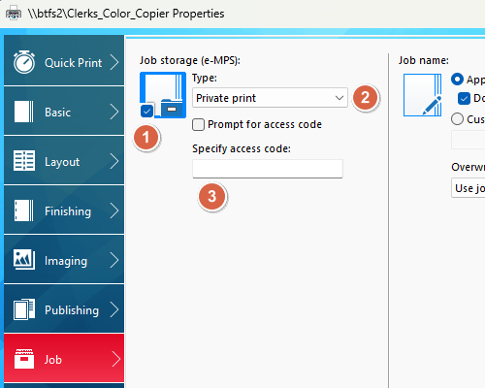
Click Okay at the bottom of the Printer Properties Window.
This returns you to the applications Print window. Click Print to send to the copier.
NOTE: The following steps occur at the Copier.
Press the Job Box icon.
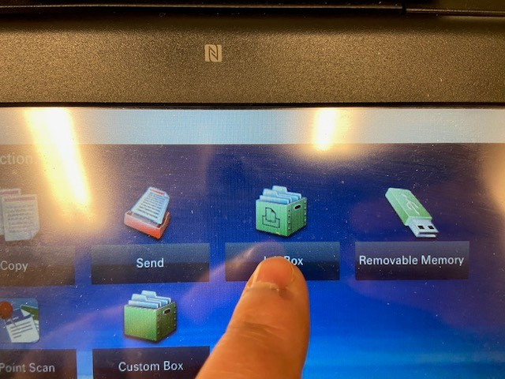
Select Print Print/Stored Job and select Open.
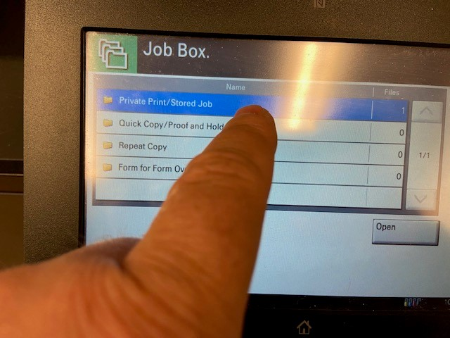
Select your username and then Open.
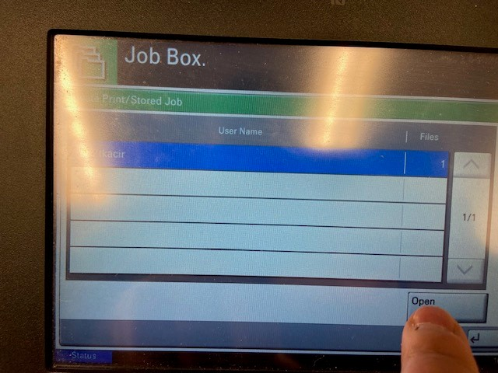
Check the box next to your stored print job and click Print.
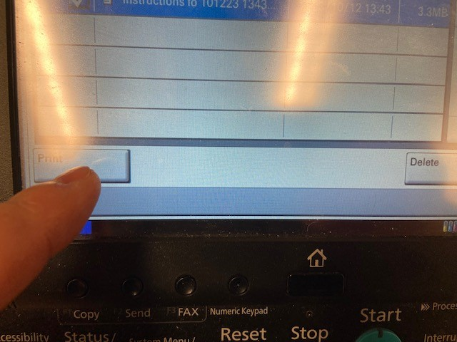
Enter the Access Code you created.
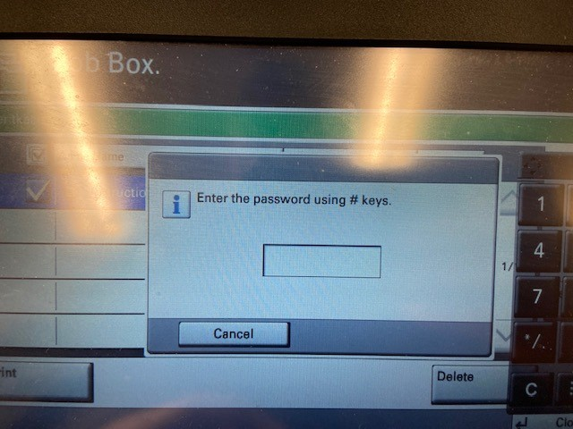
The copier will ask how many copies of your print job you want. You can enter a quantity in the box or if you only want one, leave it empty and then press the Start Print Button.
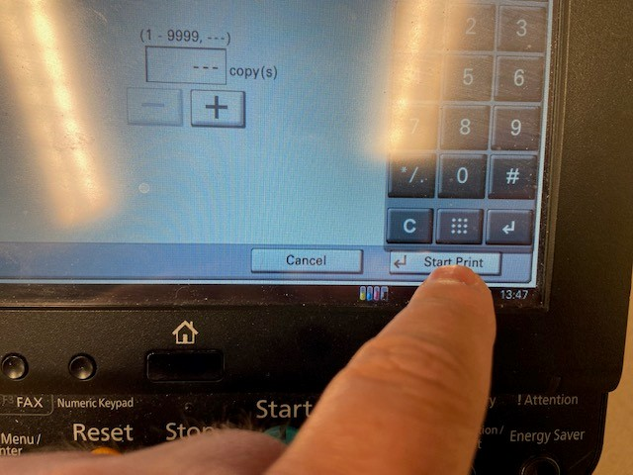
The Copier will now print your Private Print job.

