Contents
Introduction 1
Creating a New Role 2
Creating a New User 2
Inviting a New User 3
Making a User Inactive 3
Privileges 3
View All Privileges 4
Privilege details 4
Assigning Privileges 5
Creating Custom Privileges 6
Troubleshooting 7
I'm not sure which privileges I should create/assign to a Role 7
New user not showing in workspace 7

Introduction

Cloud security is simplified and streamlined into "read, create, update, delete" access levels. Within these security settings, different Privileges can be assigned to a given Role. Then, individual Users can be assigned to a single or multiple Roles.

Reminder: An Enterprise Administration Role is assigned to one or more users at a municipality. The Enterprise Admin has Full Access to all modules and can change privileges for any User.

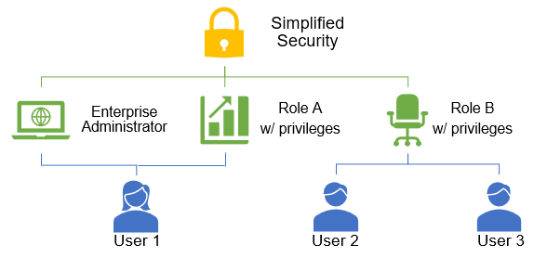

Creating a New Role
Follow these steps to create a new Role:
- Click on Administration in the Navigation pane on the left
- Click on Roles under the SECURITY header
- Click on the green CREATE button
- Type the Name of the Role (you can also provide a description, but it is not required)
- Click Save
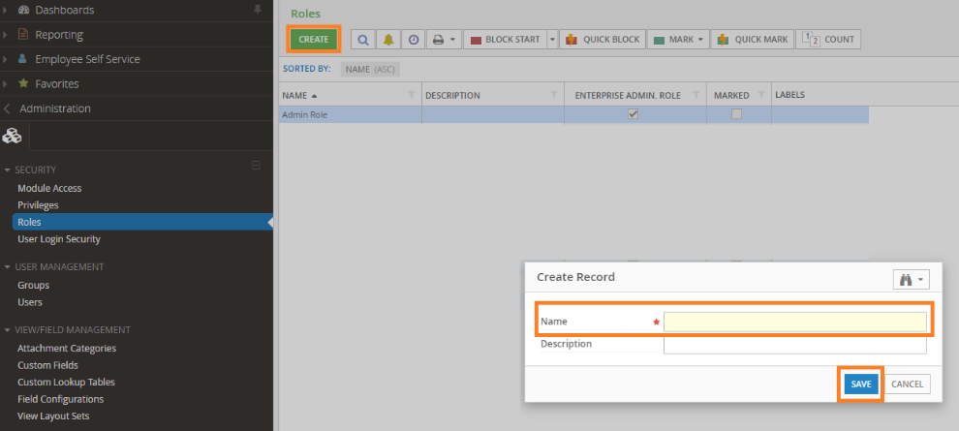

Creating a New User
Follow these steps to create a new User:
- Click on Administration in the Navigation pane on the left
- Click on Users under the USER MANAGEMENT header
- Click on the green CREATE button
- Type in the required fields: Username (ex. first initial last name), Name (first and last), and Email Address
  - Fill in the optional fields if desired
- Click Save
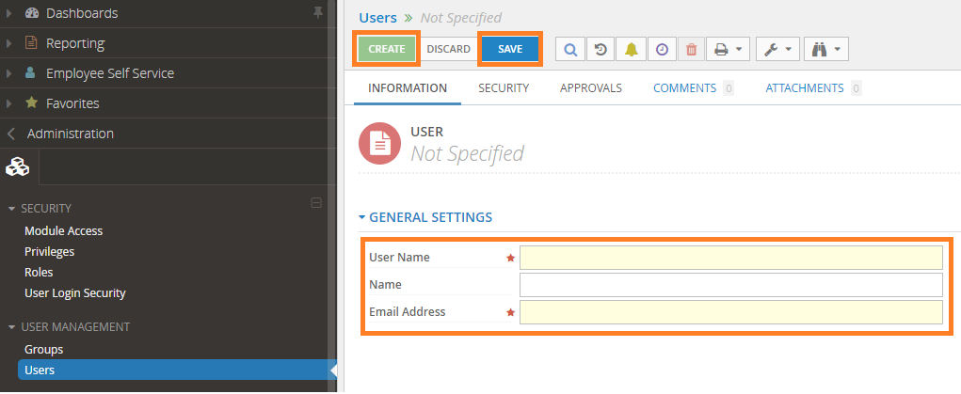

Inviting a New User
To invite an individual User, follow these steps:
- Within the Users workspace, double click on the specific user
- Click on the Tools icons in the top menu 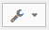
- Click Invite User…
- The Mass Invite Users window will open. Click Run Process in the bottom right corner of the window.
  - Note: The Population field will show ‘Specific Record’ and the User field will show the individual Username you are inviting. If you do not see Specific Record and the Individual Username, close the window and make sure you have double clicked and opened a specific user record.
- After the process has run, the user will receive an email with a link to your Cloud database. From there, they will be prompted to create a password.

Making a User Inactive
If an employee is no longer with your municipality and you need to remove access to Cloud, follow these steps:
- Click on Administration in the Navigation pane on the left
- Click on Users under the USER MANAGEMENT header
- Search for the user by scrolling the list or typing their username
- Double click on the username
- Click on the SECURITY tab
- Click on the Tools button in the top menu
- Click on Mark as Inactive
- If you receive a warning message saying this user performs record approvals, you will need to click Yes to make them inactive.
- Click Save

Privileges

System Privileges have pre-determined “read, create, update or delete” security. These “default” privileges can be assigned to a Role to allow users the most frequently used functionality, based on the description of the Privilege item. An example of this for a Role such as a permit clerk could be:
- System Privilege of ‘CD - Permit Creation’ which includes the ability to read, create, update, and view Permits, but not the ability to Delete.
- System Privilege of ‘LM – Lookup and Reporting’ which includes read only privileges to Land Management to see property and parcel data.

View All Privileges
To view the Community Development privileges:
- Click on Administration in the Navigation pane on the left
- Click on Privileges under the SECURITY header
- To filter the list to show Community Development system privileges, type “CD” while in this screen. All system privilege names include the abbreviation of the module at the beginning of the name, i.e. CD – Permit Creation
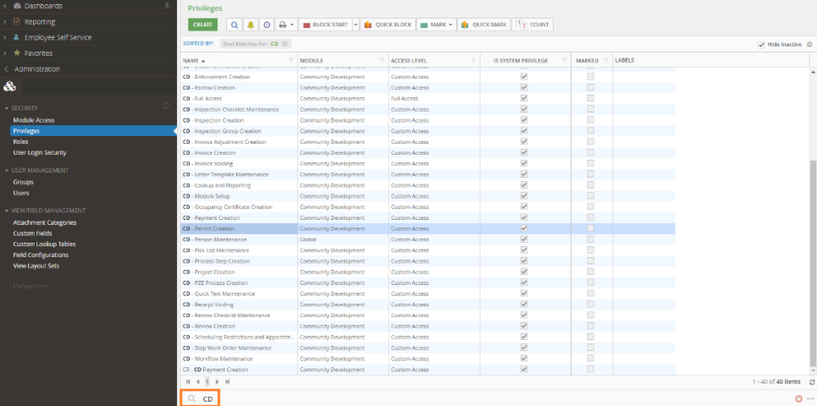

Privilege details
In the Privileges workspace, double click on the privilege item you want to view.
If you open a system privilege with custom access, you will see the radio button marked next to Custom Access and the access level defined in the box titled ITEMS. These privileges cannot be changed, but you can view what actions can be performed by expanding the marked boxes.
If you need to change what actions one or multiple users will be able to perform, see Creating Custom Privileges.
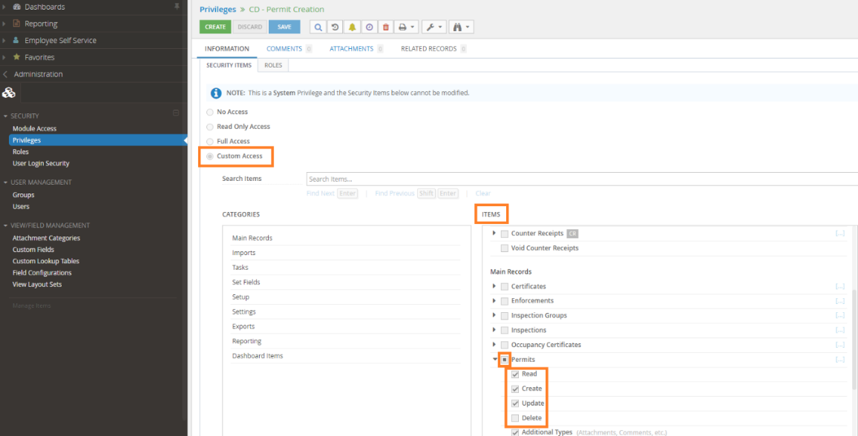

Assigning Privileges
Privileges are assigned to a role, not a user. Follow these steps:
- Open the Roles workspace
- Double click on the Role you would like to assign privileges
- In the list of PRIVILEGES AVAILABLE on the left, click once on the name of the privilege you want to grant
Note: You can click on one item, then hold Ctrl on your keyboard and select multiple items at one time
- Click on the Right arrow between the boxes to add the item(s) to the PRIVILEGES SELECTED
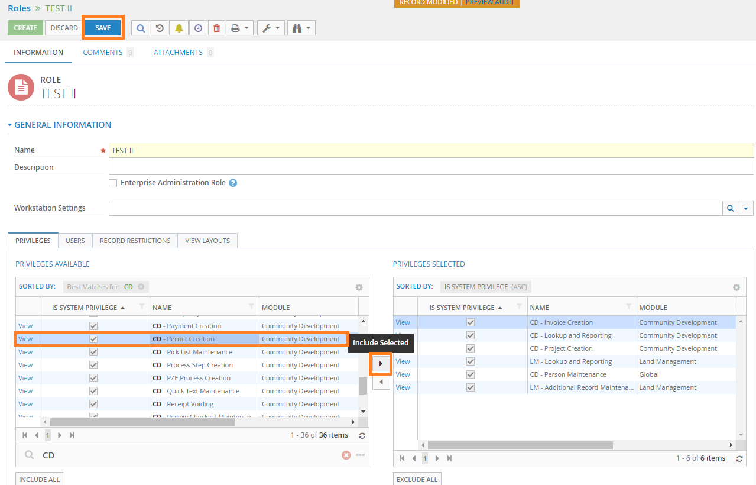
- Repeat steps 3 and 4 until you have added all of the necessary privilege items to this role
- Click Save

Creating Custom Privileges
To create a custom privilege, follow these steps:
- Open the Privileges workspace
- Search for the existing system privilege item that requires more or less access for the user
- Double click on the privilege to open the record
- Click on the Tools button in the top menu
- Click Create New Privilege Based on Current Record
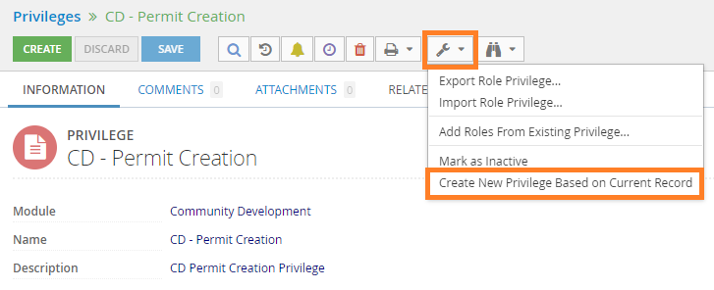
- Enter the name of the custom privilege (and a description, if needed)
Tip: adding “CD” or the module abbreviation the beginning of the name will make it easier to find when searching the other community development privileges.
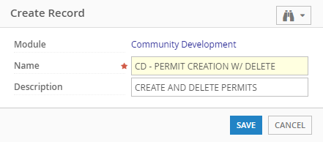
- The Security Items were copied from the system privilege. Scroll through the ITEMS to find the access you need to change. Check or uncheck the boxes next to “read, create, update, delete and additional types” as needed.
Tip: If you are going to give access to other areas of the software that are not related to the privilege you copied, include a description on the name of the custom privilege that would help you or others understand this access level in the future.
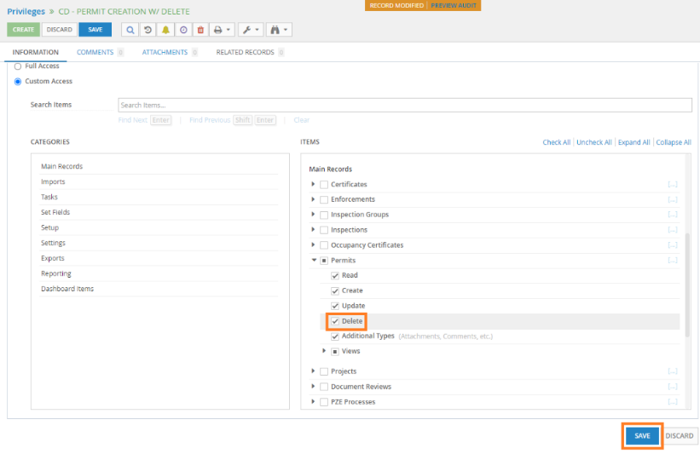

Troubleshooting

I'm not sure which privileges I should create/assign to a Role
When in doubt, start by adding the default privileges to a role. Creating custom privileges will not typically be required for most roles. Also, it's best to err on the side of granting too few privileges. If a User receives an error when trying to perform a task, the error message will provide details of the specific privilege they need. Forward the details or a screenshot of the error message to the Enterprise Administrator user so they can add the privilege to the Role. The User may need to refresh the program after their privileges have been updated so they can proceed.

New user not showing in workspace
If you do not see a newly created user in the Users workspace, check the workspace filter on the right side of the screen. The filter section can be hidden and may need to be opened using the arrow in the top right corner to view. Click on All Users under the WORKSPACES header and then search for the user again.
